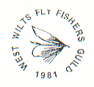WEST WILTS FLYFISHERS GUILD

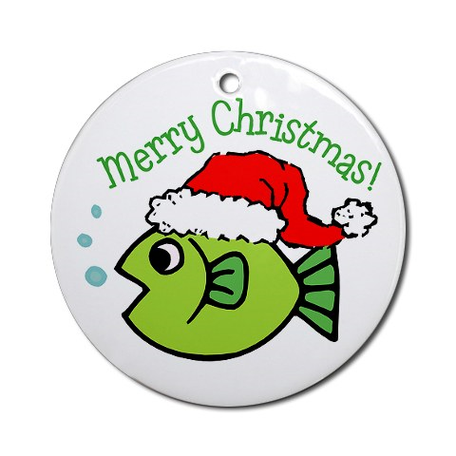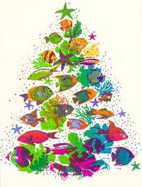

Members of the Wild Trout Trust

December 2010 Newsletter

Next Guild Meeting – Wednesday 12th January 2011
7:30pm – Quiz evening – Shaw Hotel.

RIVERS MEETING 4th NOVEMBER 2010

Review of River Frome
Our decision to stock later with smaller trout is reflected in the returns. They show a similar fishing effort and catch return as in previous years with the exception of the increased catches in 2009. A total of 80 trout were caught from 41 outings with the biggest a 17” brown caught by Jim Wheel.

Although only 6 members attended the Bank clearance day (Sunday 21st February), we were able to remove some large trunks from the beat above the flume. More numbers are required to carry out heavier work and a better attendance is hoped for on Sunday 13th February 2011. Meet on Tellisford Bridge at 9am, bring sandwiches and we will aim to finish at 1pm.

There was a lot of discussion regarding stocking or no stocking. The view reached was that with stocking the quality of the fishing is improved and without stocking the river would be viewed as a coarse fishery and therefore stocking was still the preferred option. We discussed stocking smaller fish and also stocking the Farleigh beat (if possible).

Brian Thornton suggested that, subject to Richard Cripps approval, our order could be combined with a Fullingbridge delivery which could avoid potentially expensive delivery costs. Richard has since confirmed combining the order would be the best way forward and also that the required paperwork for stocking the Frome is already in place. Brian has also confirmed that Bibury are happy with this arrangement.

#########

Review of Rivers Mole & Yeo

John Williams reported that the rivers were lightly fished this year with 14 returns, 14 outings and 133 caught (one fisherman caught 60 fish!). Over 9 outings, there was an average of 7 fish caught per outing. There were 2 sea trout caught at night (1lbs and 1 ¼ lbs) and apparently both were eaten the next morning.
The Head Weir (near where the Mole joins the Taw) has now been removed and over time will certainly increase the number of salmon and sea trout running to the Mole and Yeo.
A considerable amount of time and effort has been spent on the proposal by Devon Council to create a new public footpath which would run along a sizable section of our stretch of the Mole. We took advice from Fish Legal and various other fishing organisations which were very helpful although we didn’t have a strong position. Our lease owners (Greenwell’s) do not own the riparian rights (the land and riparian rights are owned by the farmer). We only have a right to fish. John made personal contact with all the key interested parties and was pleased to report that an acceptable alternative route has been provisionally agreed subject to final approval by the landowner.
It was noted that the Bothy may not be available next year as the Simms-Williams had decided to sell. It was agreed to recommend to the committee to send a card in appreciation of our use of the Bothy over the years.
The rent for 2011 is expected to increase from £600 to £750 per annum now that the upper Mole section comes into play.
John Sturgess referred to the previous Guild Balance sheets which recorded £400 was still unspent from the Wild Trout Trust donation. The final recommendation on stocking and all expenditure for the 2011 season would be taken by the Committee and put to the members at the AGM.

JonJ.

The Fly Tying Forum.
Our three evenings of instruction on January 19th, 26th and February 2nd
If possible, would those attending please bring along an angle–poise lamp as the extra light would be helpful. Also a square of flat MDF or chipboard, to clamp a tying vice to, would be good.We have two Fly-tying Trophies which may be awarded, one for a beginner showing exceptional promise at Fly Tying, the other for displaying advanced skills at Fly-Tying. These should be a good evenings for all, so ALL Members are most welcome.
0o0o0o0

WILD THING - OR A BAD DAY AT ‘THE OFFICE’
Your mother used to tell you things. You know the sort; don’t go out with loose women, keep your socks pulled up, your hand on your ha’penny, don’t do this, don’t do that…. You had real constraints in life. Your woollen gloves were habitually attached to each other by a length of white elastic which ran up one armhole of your school coat and down the other. Of course I put up with all this. Knew no different really……..though I must admit it proved a little embarrassing at times. When you’re doing ‘A’ levels, and clad still in short trousers, it’s a tad damaging to your street cred.
The great W.C.Fields, a notorious drinker, (Gin & Tonics a particular favourite I believe) was the owner of several marvellous quotations. One I recall, was ’Restore the quilibrium’ as he poured a copious further measure of gin into his part-empty glass. It was always gin it seems, never the tonic which required ’freshening’. He was the sceptic who said ‘First thing I do in the morning is smile. (pregnant pause, then, quickly …) Get it over with!!’ A wonderful line. He said all this, in that wonderful clipped parlance of his, ‘Never drink water, fish fornicate in it!…. Though the word fornicate was alien to him. In similar vein, I was also warned by Mother about water, and its inherent dangers. I did not learn to swim until I was fourteen, so missed out on a lot of water associated sports. [Note there, you can’t say water sports nowadays without fear of deliberately being misunderstood.] Swimming parties out on the River Thames at Mapledurham; sunbathing on the river bank with your school pals with the distinctive and evocative sound of graceful launches swishing past, their sound reverberating through the earth you lay on; or jumping off high river banks into the deep water; that sort of thing.
Past-times you enjoyed, when you used to think nothing of doing such things. Before Political Correctness, dreaded media health scares, and the urge to go to litigation and sue ‘someone’ or some authority if you drowned! What a sad, sad world we have now entered.

I swear if any good soul finds an equally good way of selling a restoration of ‘common-sense’ nowadays, to neuter PC, they’ll make an absolute fortune. They’ll be doing us all a favour. Oops, just fallen off the soap-box, and grazed my ankle, dammit! Anyway I digress; back to the plot. And as an indulgence, I change the scene. The scene magically changes at this point to a watery, wind-swept Chew reservoir. Are you still with me? Have you got this picture in your minds-eye? Then I will begin again [and, changing the tense] tell you all a story. A cautionary story:-
‘’The breeze grew stronger. It turned from a stiff breeze into tangible wind. Where the lake had been fairly flat in the middle, white caps were emerging on the wave tops. The caps became contagious and an inland sea of white horses started to meander, then canter across the mile of Chew’s middle. Gerry and Maurice had returned to shore some while earlier, perhaps anticipating the more squally weather front coming in. With some degree of ‘hurry‘, we reeled in, broke our tackle down and put it in bags and boxes.

We were not to know what lay ahead of us. A very heavy, even dangerous, crossing. At its least, you might say the experience was ‘character-forming’. When the weather blows up, reservoirs like this turn into a mini-sea. And so it proved. This was to be no exception. Only at sea before (on a deep-sea shark fishing voyage out of Looe, off the Eddystone) have I experienced the boat, itself running at full speed to run ahead of the big oncoming waves behind, be sucked back as if it were into the very trough of the wave, as a running sea came rushing in behind the boat, threatening to swamp the stern as it did so. Some of the swell, in full volume, was no more than an inch below the wooden stern. This was a one way street. Once started into our course, there was no option to retrace or change our direction, as this would have been even more perilous.

We made it back. And probably, in truth, with some ease. The very fact you are reading this proves so. We crossed the middle, running diagonally across to counter the force of the waves, and then limped our way back up the equally splashy and dangerous shoreline from the sailing club to the mooring pontoons. A laborious and rather undignified way to end our day afloat. We could just see the anchorage pontoons which were themselves being enveloped by big waves splashing wholly across their flat segmented surfaces as they pitched and tossed in the water. And there, an obviously cosy Water Board employee sat in his nice warm, silver saloon car, parked wet side of the motors shed. And watched us struggle! Struggle to anchor up, and then, tortuously, unload some mighty soggy cargo [and fish I am pleased to say] onto a pitching platform. Probably awarding us style and ‘difficulty’ points - or not!
With hindsight, [and several months later] I don’t blame him. Someone’s got to keep their pencil dry to notch up any fatalities! Ah! Statistics, a very important thing. And who would have done this (ie. the jottings) if he had failed the ’Jobsworth’ recognised ‘be of service’ code, … and fallen in?

The great Hemingway, love him or hate him, had a thing about this. It was that, the very danger of things, in an unknown situation, made you feel more alive. Approaching the edge of the abyss and looking in - before of course stepping back. Back to safety, back perhaps to reality. Being faced with danger, maybe death, makes you feel more alive. But in truth, I find you can well do without it!
Apart from giving us a scare, Chew had been bountiful. On a hard day, we had taken some fine fish which lay in the bottom of the boat. Silver-scaled and still wet from the spray. Their iridescence, and the beautiful colours of their flanks never cease to impress the eye. Chew fish are most like those fresh from the sea - fit, vibrantly beautiful, and athletic. Between us, our two boats combined, I believe we had seventeen rainbows. I tell a lie, one was a brown of around 2lb which was duly returned. I recall that Maurice took the day’s honours, catching six fish. Mostly I believe from near the reeds in Wick Green. [Mental note: shadow their boat like varnish next outing.]’’ Courteney.

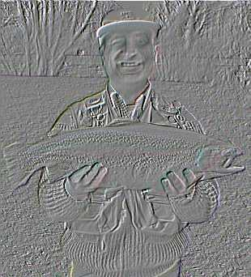
Does anyone know who this
Guild Member is, holding a huge trout?

By popular request we repeat Tim Pullens Salmon Pate Recipe
for either trout, fresh or tinned salmon.
This makes a marvellous starter, or scrumptious addition to a festive Buffet.

Salmon Pate.
220g. tinned red salmon
125g. cream cheese
Half cup of mayonnaise
Salt & pepper
2 tablespoons lime/lemon juice
125g. of melted butter (unsalted is best, then season to taste)
Mix together in food processor and chill.
Try this on brown buttered toast!

(I’ve also tried this recipe using smoked salmon or trout, it’s delicious!!…Bob.)

As there is no Guild Meeting in December, the Committee would like to thank everyone for their Membership, their participation in the Club and wish them and their Families……


Finally, I would like to Thank Courteney Fish for all his contributions to the Newsletter during the year. His writings have been witty, cultural and informative to the spectacular Art of fly-fishing.
HAPPY FISHING……BOB.
PS.

THESE ARE CRACKERS!

What is the most popular wine at Christmas? 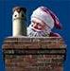
'I don't like Brussels sprouts!'

On which side do chickens have most feathers? On the outside.
Why doesn't Santa suffer from claustrophobia when he climbs down the chimney?
Because has had his flue jab.
Good King Wenceslas phoned Domino's for a pizza.
The salesgirl asked him:-
'Do you want your usual? Deep pan, crisp and even?'

How do you know Santa has to be a man?
No woman is going to wear the same outfit year after year.

Q. What happened when John ate the Christmas decorations?
A. He went down with tinsel-itis.
Colin walks into a bar with a newt on his shoulder.
The barmaid looks at the creature and asks the man what he calls it. ‘Tiny', answers Colin.
'Why's that?' enquires the barmaid.
'Because he's my newt' concludes Colin.
Why did Rudolph the red-nosed reindeer cross the road?
Because he was tied to a chicken!
Why do reindeer wear fur coats?
Because they look silly in snowsuits!.
What ties do pigs wear?......Pigstys!

MOSQUITO: An insect that makes you like flies better!

NAME THESE 6 CHRISTMAS CAROLS

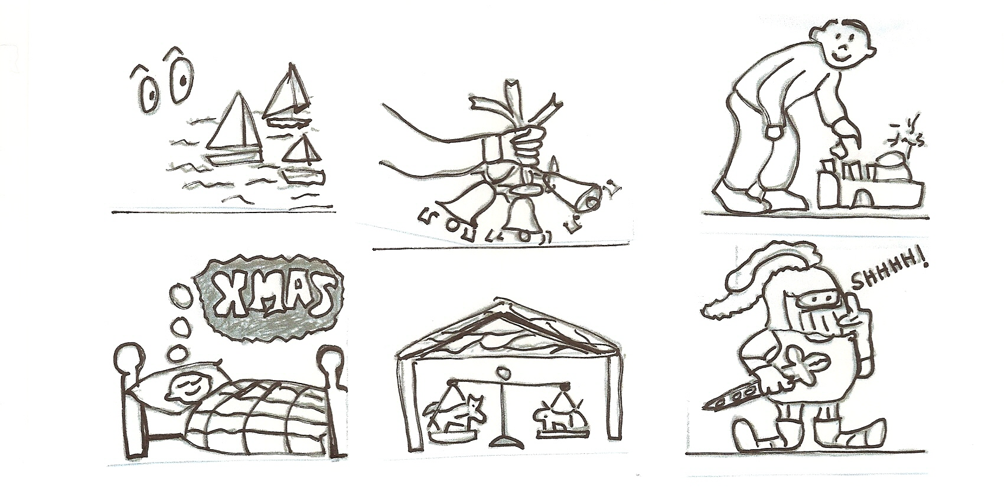

WHAT DO THESE ‘DINGBATS’ REPRESENT ?

NAME THE PHRASE OR SAYING…..

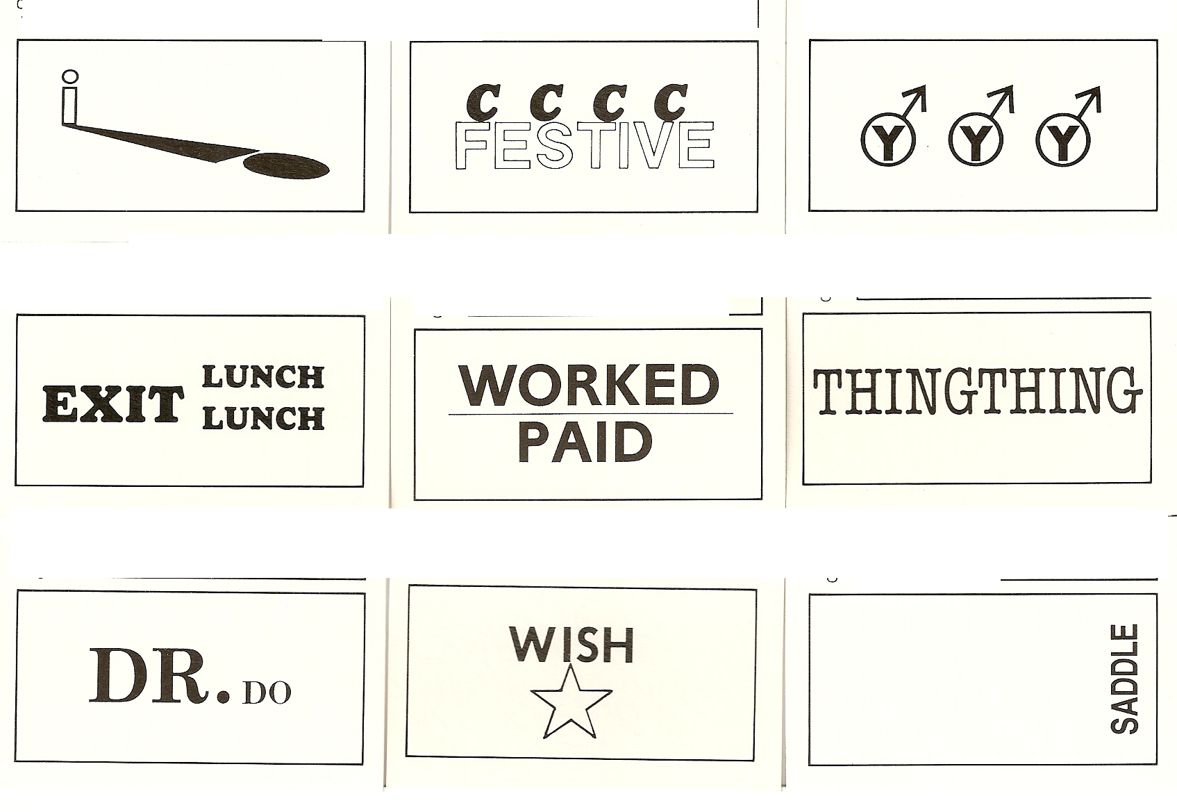
Answers next Newsletter ! ( or email me for them )

