WEST WILTS FLYFISHERS GUILD
WWFFG

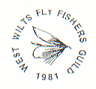

Members of the Wild Trout Trust

Website: http://wwffg.t15.org/

AUGUST/SEPTEMBER 2015 NEWSLETTER
Our next Guild Meeting – Wednesday October 14th 2015
Shaw Hotel 7.30pm
Jim Williams, AAPGI, will discuss fishing tactics with us.

Guild Meeting on Wednesday 9th September.
Eighteen Members heard Richard Cripps give a presentation entitled “The Life of the Stream.” This imaginary stream he had in mind he named the ‘Withy Brook’, it could have been a stream or beck anywhere in the country.
Withy Brook flowed and meandered through many difficulties and diversities in its life – flowing on its way to meet larger rivers and eventually to the sea. It suffered flooding, erosion of its banks, pollution, abstraction of its waters, invasive plants and creatures among a few of its challenges.
Thank You Richard for a most interesting and informative presentation adding humour as well as knowledge during the evening.

BLAGDON - WORLD FAMOUS AND FABULOUS

There is no lovelier sight in England than Blagdon from the Butcombe end at sundown. You can hear the scream of a reel and the ‘plop’ of the big trout from half a mile away. So said Harry Plunket-Greene, the famous Irish baritone opera singer and passionate fly fisherman in his excellent book ‘Where Bright Waters Meet’[1924]. And who would have the heart to dispute this, who at least half-knows the promise of its magic waters. Or have encountered its superb skyline and glorious rich-red sunsets.

Blagdon is steeped in history, legend and indeed mystery. Its hallowed notoriety has been bred from visits to its shores by the great and the good of this world, throughout the precious decades of its existence. Assorted amongst these; famous film-stars, royalty, American Presidents, business tycoons, angling ‘gods’ and hierarchy alike. They have all fished here. In the few years I have carried my rod there, I have been lucky to meet some great names like John Goddard, his pal Chris Henry; and George Melly off the telly - merely by sight of course, not to talk to. Though Maurice, Rob and I did have a short but memorable (and wheezy) chat with George Melly, then in his eighties I guess. He loved his fishing.

Rubbed shoulders with past ghosts, and walked in their footsteps; fished surely at times from the same boats. These kindred , countless celebrities have, like a legacy, left their mark. Brothers of the Angle. There are undoubtedly ghosts there. Looking over our shoulder as we fish. A wistful communion, on their part, perhaps to share, again, the attendant joy in our common quest.

Blagdon Lodge has an entirely different ’feel’ to its young pretender Chew. Being attended part-time only by reservoir staff, Blagdon can often feel wild when unattended, even dustily un-loved. You can sense there a very real presence; something akin to isolation - yet still feel a quiet sanctuary within its aged, and plastered walls. Its empty and now part-blackened brick fireplace indicating its past warmth and respite to fly-fishermen now long-since gone; perhaps to Him whose sign was the fish. Or maybe that other chap!

We entered this world on a Thursday, at the bud stage of July, 2015. And so follows a true story of the wet stuff, and even wetter flies, and a promise to keep it brief. From the somewhat more modern, but still dusty, hot-water boiler in a shabby corner of Blagdon Lodge we sipped a welcoming hot mug of coffee before we started. Whilst we did so, we watched the two or three anglers already afloat in neighbouring Home Bay. It was raining pouring - we were dry, and they were getting soaked! Somewhat like being havened in a warm caravan when it’s absolutely pelting down outside. A feeling of security purveyed - ‘Smug’ if you like.

Eventually, we set out ourselves to try the afternoon prospects from Boat No.10. After raining progressively through the morning, it proceeded to soak us three or four times more that afternoon. Daunted but not defeated, we continued. But the truth is it was very difficult fishing. No interest was shown at all (by the natives) until 8.15 that evening. When lo and behold, a few fish started peeping out of the surface. A small pod of fish visibly taking fly near the dam wall (Language Timothy!).

But it was certainly not to become a red letter day, and we managed two fish only from our extensive efforts with the dry fly. Bobs Bits; Claret Hopper; Dry Sedge and Daddy Longlegs were all paraded in front of the contenders. I say paraded, but mostly we fished these static. One rainbow and a more rare blue trout, neither of huge size, came to the net.

But you know, it was really quite enjoyable - I’ll tell you why. We had moved back close to the Lodge and what turned out to be a blue trout threw itself over my ginked-up Claret Hopper. Itself floating only inches above a dense weedbed fringing the front of the Lodge. This, more to the point, amongst one of the heaviest hatches of sedge I have ever experienced anywhere. The flies were seemingly carpeted across the water, all over the surrounding air, over most of the exposed surfaces of the boat and of course over us, and in our face! Rob had the presence of mind to capture a slice of this extra-ordinary scene we were very much ‘amongst‘. His photograph attached shows the artistry, almost poetry, of this special moment and is an artistic achievement in itself. See for yourselves this magical snapshot.
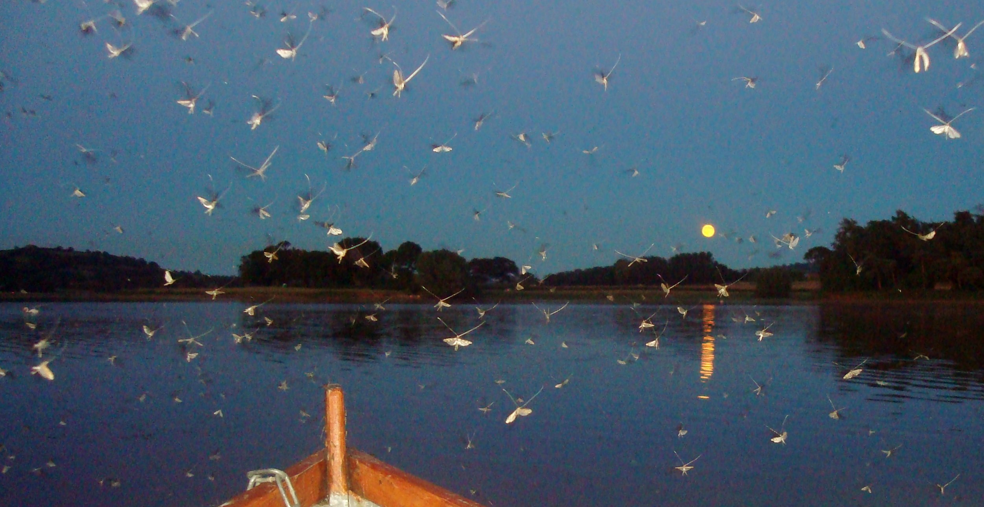

Full Moon over Blagdon Lake showing a hatch of Sedge flies July 2015

All the while, a commotion-filled fight was in hand, the trout trying to dive deeply into the sanctuary of the weedbed, the rod desperately bending to avert this, and lots of splashes and jumps, and nervousness, before it came to a grateful net. Then a mad rush back to the jetty - we were already late - to be received by an irate ranger really anxious to get home. Delayed even further, by the outboard getting seriously choked by the dense weed as we hastened back. The things you learn in adversity. Did you know that if the weed winds itself around the propeller like this, then [given clear water behind] you simply throw it off by going into reverse? This is not a wind-up….
Thought it might come in useful in future. One good turn deserves another.
Courteney Fish

Another tough day for the Guild Annual Boat Outing to Chew!
Sunday 28th June 2015
Firstly, thank you everyone who attended and especially to Robert, Andy,
Chris H and Chris W for partnering the less experienced and passing on
their knowledge. Although only 8 fish were landed between 12 anglers we did enjoy the day and all agreed it was a good idea to stop for lunch at the Lodge and regroup for the afternoon session.
On the day the fish were very difficult to find and even more difficult to catch.
The Results:-
Congratulations to Chris Holt for winning The Chew Cup with the best bag and also the best fish, a brown trout of 4lbs 6ozs.
Chris Holt…………….3 fish….1lbs 10oz, 4lbs and a 4lbs 6oz brown trout
Andy Greatwood…2 fish….3lbs. 9oz and 2lbs. 10oz
Chris Winsor………..1 fish….3lbs 8oz
Bryan Hussey……….1 fish….3lbs 6oz brown trout
Jon Jonik….………….1 fish…..3lbs 9oz
Jon Jonik

A Lunchtime Break for Members fishing the Chew Boat Day
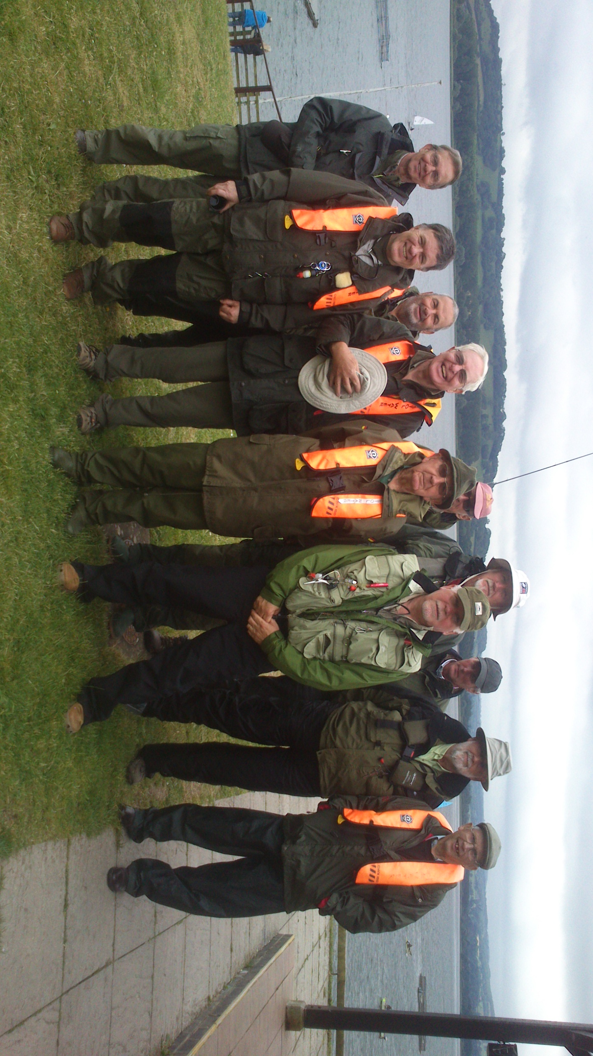
LOOKING FORWARD….
.Wednesday October 14th – Guild meeting. Guest Speaker – Jim Williams – AAPGI Master Fly Fishing Instructor. Vision Tackle World Team Member.

Sunday October 18th October 2015
Guild Christmas Hamper Competition – Mill Farm Trout Lakes. Worton, Nr. Devizes. Sat Nav:SN10 5UW. Tel:01380 813138.
All Members are invited to fish the two lakes from a 9:00am start to the 3:00pm weigh-in, on a 3 fish ticket. There is a Great Christmas Hamper to be won for the heaviest bag, not forgetting the bottle of ‘fishing plonk’ for the heaviest trout. Please abide by the Fisheries rules.

‘SPIDERS’
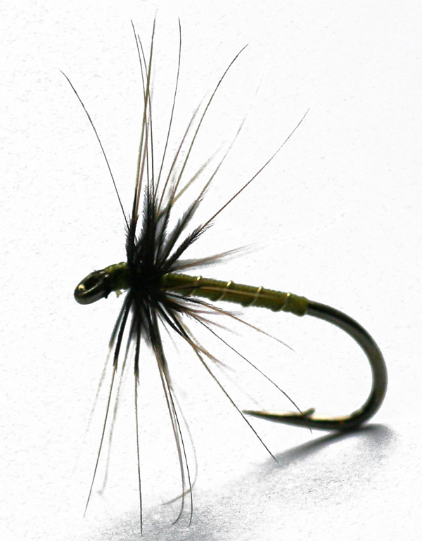
Spider flies are typically dressed with a very minimal hackle, often only one and a half turns of hackle feather, just as traditional North Country spiders or Clyde style spiders have been tied for many years. Generally flies are tied to imitate hatches, but North Country flies have nothing to do with imitating spiders!
This spider is the name given over the years because, when dry before immersion, the soft hackle looks like the legs of a large spider!
Anglers have been tying Spider flies for over 300 years and they still catch fish. These are not imitation patterns such as one would exactly match, perhaps a fly like the blue winged olive – they are impressionistic patterns.
Have YOU used spiders to great effect?

I remember as a lad fishing the Cumbrian River Eden and using the ‘snipe & purple’ and catching good bags of wild brownies. In July’s edition of ‘Salmon & Trout’ the ‘spider’ is featured.

Britain faces an invasion of venomous False Widow spiders as warm conditions herald a population boom

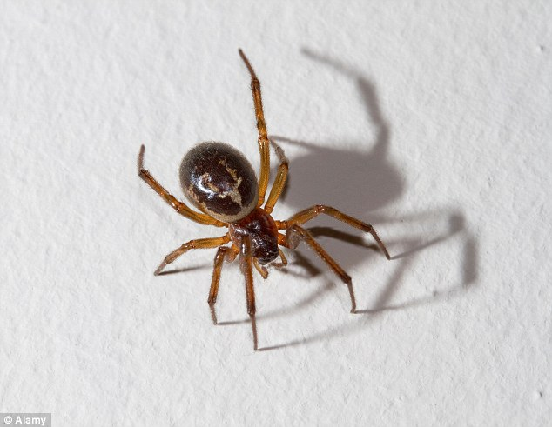
Warm weather throughout summer created ideal conditions for this spider
The ‘false widow’ has been named the most venomous spider in Britain
They are set to be heading indoors in the coming weeks as temperatures drop
Reactions to the spiders' venom can be severe, although bites are rare.

Fullingbridge - Fishing & BBQ Wed 8th July
Always a very popular Guild event, this year fifteen members participated. Some made a 3pm start but those arriving later caught good fish and may even have had the best of the day’s sport.
The weather was kind – no rain, although the breeze from the Dam end made casting difficult for some.
The fish were up in the water and when in the right frame of mind, were taking slowly fished imitative patterns - nymphs, emergers, dries, hoppers etc. particularly in the last couple of hours.
Congratulations to John Sheppard who won the Fullingbridge ‘Ron Douch Tankard’ for the heaviest first two fish landed, weighing 3.5lbs. and to Brian Hussey who won the bottle of wine for the heaviest individual fish, weighing 2.5lbs.
The BBQ has attained legendary status over the years, so it was very brave and generous of our Chairman Mike to take on the role of Head Chef this year, and sacrifice the chance to fish; but with the help of his wife Ina he put on an absolute feast, AND did the washing-up.
Many Thanks to Mike and Ina.
Fullingbridge is a superb location and we are very grateful to the syndicate for their hospitality.
Photos – THIS IS HOW IT’S DONE !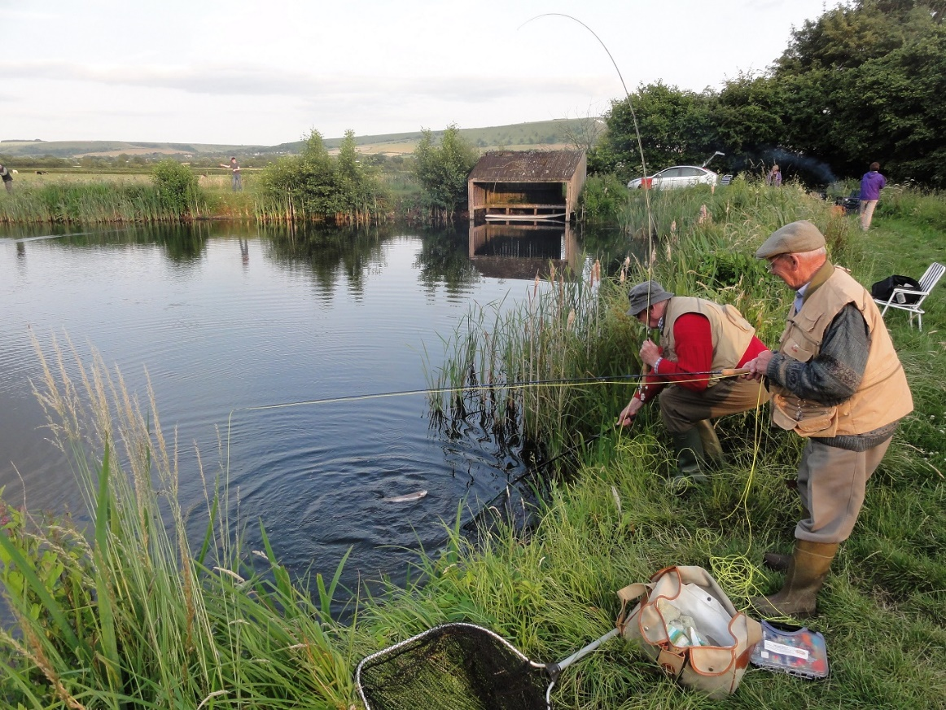

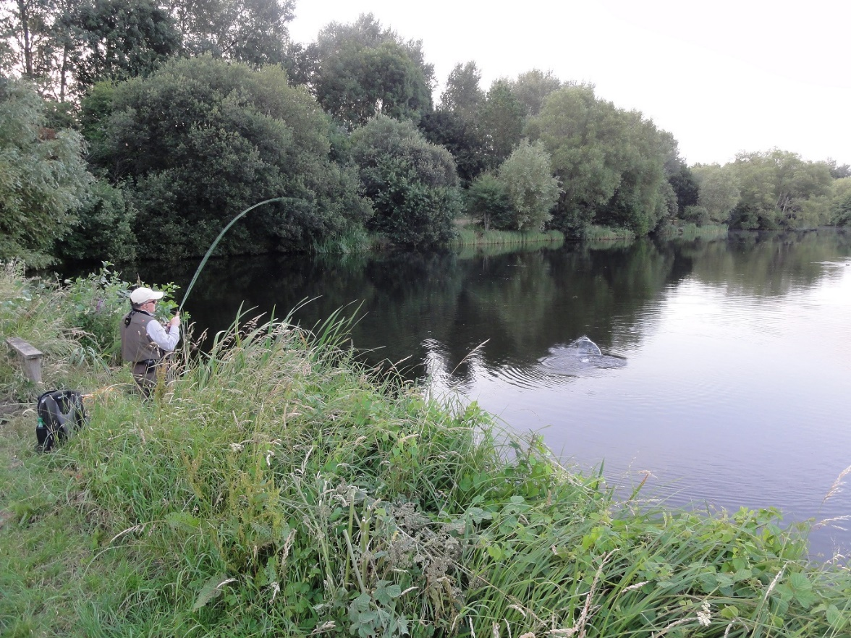

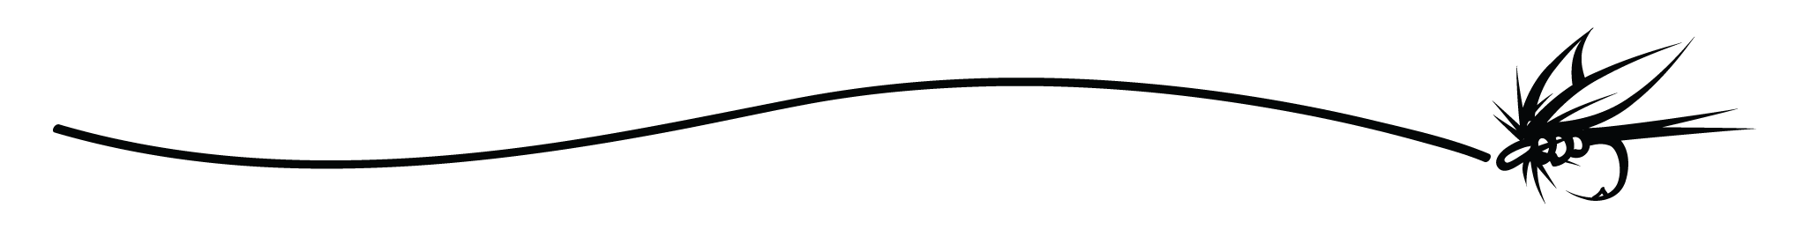
Shut off the world for a minute or two and CHILAX!!
See the Golden Damsel (fish)!
Sound on, Control & click……
https://www.youtube.com/embed/mcbHKAWIk3I

0o0o0o0o0

A 400-million-year-old blood-sucking creature once eaten by Vikings tops the Environment Agency’s list of England’s rarest fish.
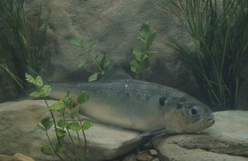
A 400-million-year-old, rare, blood-sucking creature once eaten by Vikings - and a relic from the Ice Age, tops the Environment Agency’s ‘secret seven’ list of England’s rarest fish, which it unveiled today.
The seven species are lamprey, Arctic charr, vendace, spined loach, allis shad, twaite shad and smelt. All seven species of fish are a conservation priority at a national and international level.
The reasons for their previous decline include historically poor water quality, barriers to migration and a changing climate. But now, all seven are starting to thrive again - thanks to work by the Environment Agency and other conservation groups.
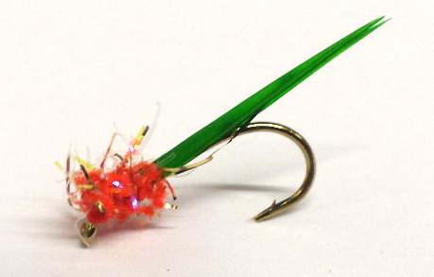
This is a good time of year for The Pin Fry Fly!

Guild’s Photographic Competition

More pictures required for our Competition please.
Send a photo which is ‘loosely’ related to our hobby to Robert.is@trouthooker.net

PS., Diary Date,

WWFFG Annual Dinner
Friday 20th November at the Shaw Hotel

Menu and Raffle details to follow in the October Newsletter

HAPPY FISHING……BOB

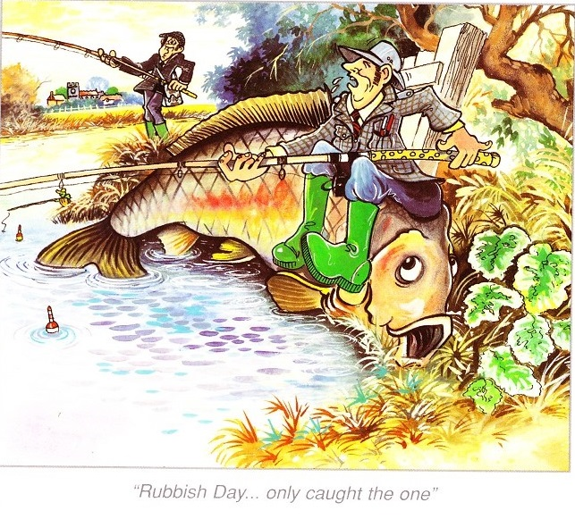

“Rubbish Day - only caught the one!”

