


Members of the Wild Trout Trust

Website: http://wwffg.tripod.com/

JANUARY 2012 NEWSLETTER

The ANNUAL GENERAL MEETING takes place on Wednesday 8th February at the Shaw Country Hotel commencing at 7:30pm.

The presentation to the Trophy and Cup winners for 2011 will take place after The February AGM ceremony.
The list of winners is as follows….

The Henderson Trophy……Andy Greatwood………..9lbs.4ozs.

The Nyeford Trophy……. Stephen Davies………...4lbs.15ozs.

The Bill Avon Shield……….Colin Burbedge…………….14lbs.9ozs.

The Spinnaker Cup………….Tim Pullen……………………..10lbs.12ozs.

The J. Turk Shield………..Colin Burbedge…………….12lbs.6ozs.

Chew Boat Cup……………....Tim Pullen……………………..1lb.10ozs.

The Chairman’s Vic Willcox Memorial Trophy…..Gerry Tinson.

Wilf Sleightholme Tellisford Shield……………………..Roger Henderson,

The River Brown Trophy…………………………………………..Jim Wheel.

The first Guild Meeting of the Year took place on 11th January followed by
THE QUIZ…..
Around 15 Members turned out to be quizzed and mystified by John Dixon and Richard Cripps. As always, what a fascinating evening we had.
John and Richard entertained us on a January evening at a time when we needed our spirits to be rekindled after the holiday season. They made us delve deep into our knowledge of angling,. Indeed, they have been doing this for many years with great humour and their quizzes just seem to get better and better!
We were split into teams of 3 and given Question Headings such as –
‘Guess these latest tackle prices from the John Norris Catalogue’
We were given a list of items such as 444 lines and Orvis and Hardy Reels to price up.
On a sheet of paper headed ‘Guesstimation’ we had to decide on the sizes of hooks and fine lines which were taped to the page – easier said than done!
Bags of sand were supplied for us to guess the weight- was it 8ozs.or 12?!
There were fish questions like where is the caudal fin? A simple poser but could our team remember? N0! We were shown pictures of angling celebrities – disguised or looking younger, very tricky. What a superb quiz evening!
‘The Dog Nobblers’ won with 52 points – they seemed to know ALL the answers!
All the teams ended up winners though - with chocolates and Jelly Babies dished out.
We appreciate the obvious hard work and time involved in making this evening such a resounding success. Thanks John and Richard. Oh! Can we book you for next year?

AUCTION of Angling Items
After our Guild Meeting on Wednesday MARCH 14th we shall be holding an auction of fishing equipment. Most items in the sale were owned by the Late Tam Pearce.
His son, Simon has asked us to conduct this auction and the proceeds to be sent to a Charity of his choice.
We shall put together a sale list catalogue which will be published in February’s Newsletter.
This could also be a good opportunity for Members who have surplus tackle or fishing memorabilia to have it auctioned, so please let me (Robert) know ASAP and I will include your items separately within the catalogue.

Sunday 19th February – Bank Clearing at Tellisford
As in previous years, we will meet on the bridge at 09.00am and it would obviously be great if as many members as possible , especially River Members, turn up please, to show their support and bring with them a bow saw if they have one, as well as a flask of tea/coffee & perhaps a bite to eat. Last year it took us about three hours of light work.
Brambles and small branches overhead and across the path are a problem and will get worse with spring growth - between them they either snag rods or wellies so suggest garden 'loppers' would be useful tools to add to the bow saws
If those able to attend could let Jim Wheel or Roger Henderson (who have taken over from Jon as Riverkeepers) know before the day then that would be great.
After the winter winds there are a couple of problems that need to be put right…

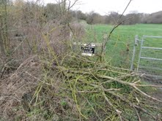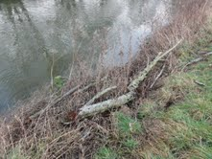
Photos taken by Roger

BRISTOL WATERS FISHERIES
The costs will soon be available at our website but the main fishing charges will be:
2012 prices (per rod, per day)
Boat; …… Chew Valley £35.00. Blagdon £30.00. Litton £65.00
Bank;……. Chew Valley £17.00. Blagdon £20.00. Barrows £15.00
Season Permits; All Waters £700.00. Chew & Barrows £570.00,
Barrows £435.00, Weekend £275.00.
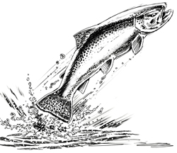

A WINTER’S DAY - FISHING THE WYLIE

Gerry’s first ever grayling.... and here’s his second
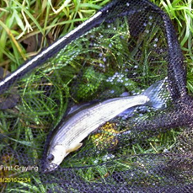
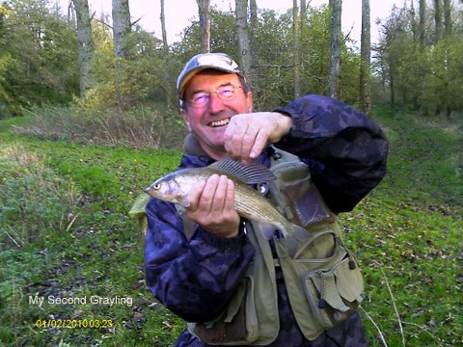

WYLIE REPORT FROM GERRY TINSON
The day began with just about perfect weather which is always a bonus when going fishing. We, that is Brian Thornton, Maurice Dyer, Gerry Tinson, Gerry Barnes, Malcolm Bond and Mike Harris arrived at the lane leading to Eastleigh Farm on time with some guidance from Richard Cripps. The decision was made as to who fished which beat. Gerry B, Malcolm and Mike took the top beat and we headed to the lower beat, calling in first to see where the fishing was at Roz Walker’s Farm. After making ourselves known to Roz we took a look at the stretch of the Wylye that could be fished there, it could have been a long walk from the farm but thanks to Brian’s 4x4 it made the trip a lot easier. Richard then led us to the lower beat, which belonged to Salisbury and District - about 100 yards of water and it did look good. Richard as always was very helpful instructing us as to where our beat began, where the favourite holes were and the Flies to try. Wishing us well and waving goodbye Richard left to make sure the others were OK on the top beat. Our stretch was in all, easy to fish with plenty of room for the three of us without crowding each other. We tackled up and set off, there were plenty of fish as I discovered by spooking them with my shadow, so the order of the day from then on was stealth! We fished till lunch time then returning to the water we stayed fishing till around 3.30, the catch was Maurice 1 Grayling 4 browns (returned), Gerry T 2 Grayling (1 taken) a very good day and well worth it. I think the purchase of some days at Roz’s for the Browns next season would be a Good Idea.

More Wylie Notes - from Mike H.
Last Sunday (13th November 2011) was a good day. Six of us attended (or at least 6 had attended before Richard split us up to fish, others may have come after
that) and myself, Gerry Barnes and Malcolm Bond fished the upper beats.
I had three small grayling (one off the top on a dry fly), Malcolm had
one up to lunch time and Gerry B. blanked. It was glorious weather and a
real pleasure to be out. Christened the new rod by the way.

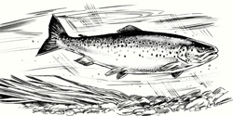

FISH FINS
#Three’s a crowd
Shrimps are driven by ‘dark passions’. According to new research. The monogamous Lysmata Amboinensis will attack and kill its fellow creatures if there are more than two in a group.
A researcher from the University of Tubingen in Germany said the hermaphrodites’ behaviour was down to ‘competition for food’.

#A light snack
Small squid and octopus living deep in the ocean avoid most predators by remaining almost completely transparent. But their ‘invisibility’ could be a matter of life or death when hunted by headlight fish – some species turn red in the blink of an eye. It is only the light that makes them switch, US scientists have found.

Bead Head (BH) Lime Dancer - Trout Streamer Fly
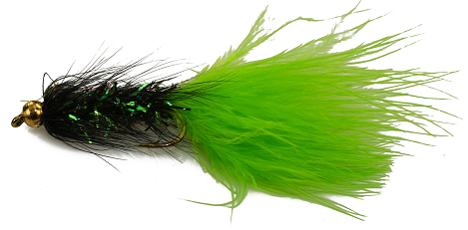
The Bead Head (BH) Lime Dancer is a great Trout Fly. This fly is fished in the style of Bead Heads or Gold Heads or Lures

A Fly for early Season
The bead in the Bead Head (BH) Lime Dancer makes them sink very well and is ideal for fishing deep in lakes.
A very successful and radiant pattern with an exciting movement from its tail which excites predatory trout. The Orange or the Lime Dancer catches fish year after year and is one of the essential flies for fishing in spring. The movement of the maribou tail is similar to the natural damsel nymph. Head and palmered hackles give additional interesting action.
The weighted bead allows an up and down motion depending on the type of retrieve.
This fly has caught trout, not only in its original intended environment (stillwaters)
but also in rivers and lakes around the world.

Who Listens? An e-mail from America……
ENVIRONMENTAL DAMAGE: IT’S PROPORTIONAL TO HUMAN POPULATION.
One by one, the great ocean fisheries are being destroyed by overfishing,
including the storied Grand Banks off Newfoundland. Elsewhere, ocean gyres
(circulations) have trapped gigantic "floating garbage patches," consisting
of barely-buoyant pieces of man-made plastics that threaten marine life. On
land, the Green Revolution saved billions of lives from starvation in the
20th century, but at the cost of lower groundwater levels over much of the
globe and depleted reserves of phosphate rock. It would be impossible to
repeat the Green Revolution today. Moreover, population growth pushes oil
production ever closer to the dreaded Hubbert Peak, even as atmospheric
carbon from burning fossil fuel contributes to global warming and lowers
the pH of the oceans, with serious environmental consequences. The lesson
is clear: excessive population is damaging our environment at a rate that
far exceeds the natural recovery rate. What then determines the population?

WHAT’S THIS? A 15 pounder from Mill Farm. Caught end of season, last year on a #14 gold head hares ear. For the size and age of the fish it had beautiful markings and not dark coloured at all. I couldn’t decide whether to set up the trout in a case -£900 (£1500 in a bow-fronted case) or have it hot-smoked at Sutton Veny - £16?
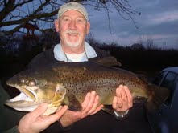

Mmmmm! Delicious!!

Let’s hope 2012 will bring us some great and memorable days out - doing what we enjoy most!
HAPPY FISHING….BOB
PS.
A lawyer boarded a flight in London, with a box of frozen crabs He asked a blonde Geordie stewardess to take care of them for him so she took the box and promised to put it in the crew's refrigerator.
He advised her that he was holding her personally responsible for them staying frozen, mentioning in a very haughty manner that he was a lawyer and proceeded to rant at her about what would happen if she let them thaw out.
Needless to say, she was annoyed by his behaviour.
Shortly before landing in Newcastle, she used the intercom to announce to the entire cabin, "Would the lawyer who gave me the crabs in London please raise his hand?"
Not one hand went up ...... so she took them home and ate them.
Two lessons here:
1. Lawyers aren't as smart as they think they are.

2. Blondes aren't as dumb as most folk think!

ooooOOOOoooo

RUNNING WATER
Far from the bondage of bricks and mortar,
Far from the hurry of urgent deeds,
Give me to live by the running water-
Running water and whispering reeds.

Let it be where there are mills and hatches,
And water meadows-where kingcups grow,
And bridges to lean on, from whence one catches
A fugitive glimpse of the trout below,

In a little cottage-with friendly neighbours,
With books and a rod for my simple needs,-
So shall the soul find rest from its labours
By running water and whispering reeds.

By Dr E.A. Barton, published 1943
(Thanks Roger H. for this article. Hopefully will include a short descriptive story by Dr Barton next time.)

Obituaries

Ron Douch passed away peacefully on 27th December 2011

"Ron Douch.

On the 12th January, representatives of The Guild attended a Commemorative Service held at Semington Crematorium to the memory of Ron Douch who died on the 27th December.
Ron was an enthusiastic fisherman since his very early boyhood days which over the years came to embrace all aspects of the sport. A member of The Guild for well over a decade he will be remembered for his organising skills during his years as the 'members' representative on the Committee. A Vice-President for many years, his contribution to The Guild was recognised by being elected an Honorary Member in 2011. Ron's spirited, knowledgeable and always entertaining presence as a companion 'rod' at the bankside, or afloat, will be missed."
J.S.

We also sadly relate that Guild Member Stephen Davies passed away last week.

The funeral will be held at the Semington Crematorium on Tuesday 24th January at 11.30am.

RIP

